- Draw the V-Model diagram on paper or using any digital tool, and clearly label each phase with both the developer and tester roles involved at each step.

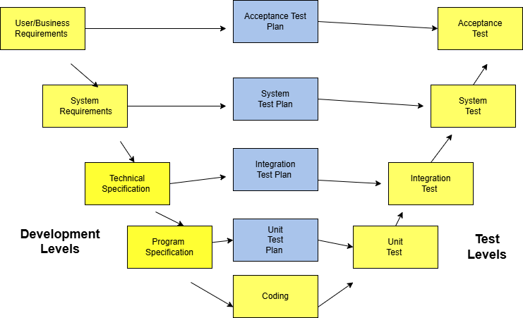

- Pick any app you use daily (like Zomato, Instagram, or Paytm) and write a short table mapping each SDLC phase (Requirement, Design, Coding, Testing, Deployment, Maintenance) to a real activity that would happen for that app
Ans=> in instagram,
Requirement | Collect requirements for a new feature, such as allowing users to upload longer videos.
Design | UI/UX designers create screen layouts, user flow, and database design for the new feature.
Coding | Developers write code for features like posting images, stories, reels.
Testing | testers check whether login, posting, messaging, notifications and create report.
Deployment | After successful testing, the updated version of Instagram
Maintenance | Developers fix bugs, improve performance, release security updates on user feedback.

- For each phase of the V-Model, list one specific testing activity that should be performed, using examples from a food delivery app (like Swiggy or Zomato).<br><br><em><strong>Hint:</strong> For example, during 'System Testing', you might test if the order placement works end-to-end.</em>
Ans=>

V-Model Phase |  | Example in Food Delivery App
Acceptance Testing |  | Verify users can search restaurants, place orders, and make payments as requirements.
System Testing |  | Test select restaurant → add items → checkout → payment → order.
Integration Testing |  | Test cart, payment gateway, restaurant system, and order tracking work correctly?
Unit Testing |  | Check if the coupon calculation apply discounts correctly?
Coding Phase |  | Developers fix issues and testers execute testing after code completion.

- Compare the V-Model and RAD Model by listing 3 strengths and 2 weaknesses of each, focusing on how testing is handled in both models.
Ans=> V-Model
Strengths,
- This is a highly disciplined model and Phases are completed one at a time
- Works well for smaller projects where requirements are very well understood
- Easy to manage due to the rigidity of the model.

Weaknesses,
- High risk and uncertainty.
- Not a good model for complex and object-oriented projects.

Handle testing = is handled in parallel with development. Each development phase has a corresponding testing phase, and test planning starts early. waiting until coding is completed.

